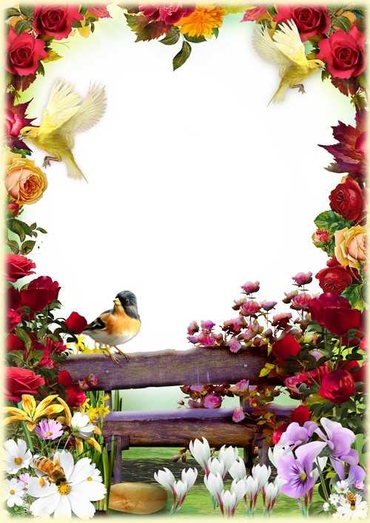

Caldwell University Music Department

Spring Concert
Featuring the Caldwell University Chorale
&
the Caldwell University Wind Ensemble

Monday, May 2, 2022
7:00 PM
Student Center Auditorium

Caldwell University Chorale
Laura Greenwald, Director Eric Olsen, Accompanist

Alleluia William Boyce

Dominican Magnificat Feargal King

Flight Song Kim André Arneson

The Path you Walk Upon Catherine Dalton
Rebecca Vega, flute; Tatyana Rodriguez, student conductor

If you can walk you can dance Elizabeth Alexander
Christina McCoy, claves

i thank you, God Elliot Z. Levine
Maria Tavarez, soloist

What do I know? Ed Sheeran, arr. A. Snyder
Caio Elias, guitar & soloist Christina McCoy, cajón

Let the River Run Carly Simon arr. Craig Hella Johnson
Noelia Figuereo, Christina McCoy, percussion; Julia Weniger, string bass

How Can I Keep from Singing? Gwyneth Walker

Prayer for Ukraine Mykola Lysenko

Sopranos: Agnes Berki~, Kasandra Gonzalez, J. Alex Medrano, Alicia Santamaria,
Krystal Tardif, Maria Tavarez++, Julie White
Altos: Noreen Abedrabbo, Donna Graham*, Sarah Morris, Hannah Quiros,
Kim Rabbia, Tatyana Rodriguez
Tenor/Bass: Mark Aro*, Marcos DeLa Cruz, Caio Elias, Aashutosh Khatiwada,
Nicholas Peteya+~, Logan Schaefer

+Alumni
*Community Member
++Graduating Senior
~Faculty/Staff

Presentation of Awards

Marina Carroll Scholarship: Tatyana Rodriguez

Gloria’s Gift Scholarship: Noreen Abedrabbo

~~~~~~~~~~~~~~~~~~~~~

Wind Ensemble
Rebecca Vega, Director

Festivo Vaclav Nelhybel
(1919-1996)

Blue and Green Music Samuel R. Hazo
(b. 1966)
Julie White, Guest Conductor

First Suite in Eb for Military Band (1909) Gustav Holst
- Chaconne (1874-1934)
- Intermezzo
- March

Three Miniatures for Winds and Percussion Robert Sheldon
- Joyful Dance (b. 1954)
- Simple Song
- Celebration
Alicia Santamaria, Guest Conductor

Highlights from Wicked Stephen Schwartz,
(b. 1948)
arr. Michael Brown

Thank you to: the Administration of Caldwell University for their support of our programs; Nicholas Peteya, Dan Burg, James Small, Matt Netter and the IT crew for their extraordinary efforts in video and sound production; Roxanne Knott-Kuczborski and James Carroll for their generous Music Scholarships; Barbara Budris and our work study students for administration; our students, faculty, staff and community members for their participation, support and joy in making music together again!

Wind Ensemble

Flute
Amanda DeForne++
Katie DiGangi*
Kevin Galarza
Toni Genuario+
Lauren Marks
Janet Portillo
Julie White

Oboe
Alyssa Ahearn*

Clarinet
Micaela Andrews+~
Dan Burg~
Michelle Graziano+
Sarah Morris
Alyssa Pagán
Evenny Peralta
Lauren Podkul+
Hayley Wilderotter*

Bass Clarinet
Martha Boughner*

Bassoon
Jess Bergen*

Alto Saxophone
Noreen Abedrabbo
Pedro Liriano+
Isaiah Murray

Tenor Saxophone
Ferris Mahadeen*

Bari Saxophone
Marcos De La Cruz Jr

Trumpet
Joe Bergen~
Michael Hirsch*
Stephanie Mancilla
Matt Purden*
Tatyana Rodriguez
Alicia Santamaria

French Horn
Alison Ferrell~
Nathan Scott*

Trombone
Adam Criaris+
Anthony Ecanosti+
Randy Heuer*
Tim Self*

Baritone
Melissa Kay+~
Adam Lasek

Tuba
Matthew Candelario
Christian Severin

String Bass
Julia Weniger

Percussion
Sonia Casiano
Noelia Figuereo
John Greuter
Myles Little
Christina McCoy
Kimberly Rabbia
Logan Schaefer
Ashley Zafarino++

+Alumni
*Community Member
++Graduating Senior
~Faculty/Staff

